DealerSocket

.............................
Best Practices
Up Process - New Prospect Accountability
Entering new prospects is the most powerful practice to good CRM management--quantity and quality. You pay good money to attract customers to your dealership. You want to make sure you extract the most from each opportunity.
DealerSocket has built-in management tools and checkpoints to ensure every customer goes through the process you have established.
Checkpoint 1: MGR Dashboard Desk Log
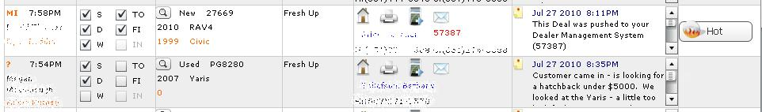

Use the Desk Log to make sure every store visit gets logged accurately into DealerSocket. Dealerships who have air-tight up processes generally require the sales person to enter the new prospect before they approach the sales desk.
You can then monitor this from the Desk Log. If the customer does not show up on the Desk Log, then the sales rep did something wrong. For fresh-ups, the sales rep needs to log the prospect and make sure the Store Visit checkbox is marked on the Sales Status. For Be-Backs, the sales rep needs to update the Sales Status as a Store Visit for that day.
Begin to enforce this rule and sales reps will begin to form good habits.
Checkpoint 2: Sales Checkout
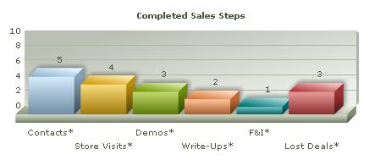
The Sales Checkout will give you a detailed view into the day of your sales staff. During one-on-ones, a common best practice is to click on the "Contacts" graph under Completed Sales Steps. This will pull a report of any customers that the sales rep interacted with during the given date range.

By holding your sales staff accountable with a check-out process, you will better ensure that all your prospects are being channeled through DealerSocket.

Checkpoint 3: Sales OTDB Report
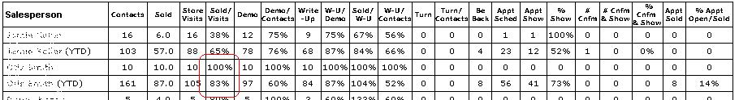

The sales OTDB (Opportunity To Do Business) Report shows how many prospects were entered into the system and how well the sales rep moved those prospects through the sales steps.

The "Sold/Visits" column is very telling. This should be an accurate percentage of their true closing ratio. If this number is too high, then the sales rep is not putting in all their ups. Review this on a monthly basis.

Result

Use these 3 checkpoints to make sure the sales reps are sticking to your up process. The car business is about percentages. Enforcing this will increase your opportunities and increase your sales.
~Service Advisor~
Strategic Services Consultant
Phone: ~Sales Person Phone~
Email: ~Reply Email Address~
Support Phone: 949.900.0300 ext. 3
Support Email: support@dealersocket.com



