
.............................
Best Practices
Increasing Email Capture Rates
Dealerships that understand CRM understand that Contact Information equals Money. Many dealerships put a heavy focus on email capture.Not only do emails reduce your overall marketing budget, but good targeted email marketing can drive traffic into your store.
DealerSocket gives you multiple ways to ensure your staff is capturing email addresses.
1. Set the Expectation

The most important thing you can do is set the expectation with your staff. And make it specific. A good goal is 40% email capture for each sales rep. 33% is a minimum.

2. Desk Log - Contact Information

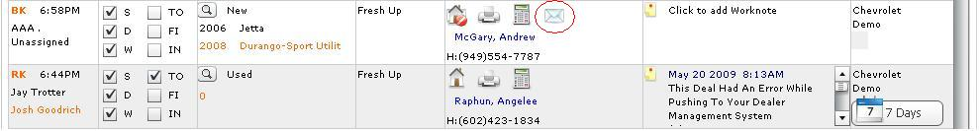

The Desk Log is the first place you should check for contact information. Here you can easily verify your staff is getting multiple points of contact. In order of importance you should be looking for:
1. Phone Numbers
a. Cell Phone
b. Work Phone
c. Home Phone
2. Email Address
3. Mailing Address
All this information is available from the Desk Log. Inspect each record. If the sales rep captured an email address, an envelope icon will appear.

3. Team Effort

Getting good data is a team effort -- sales, desk managers, BDC reps, service advisors, F&I. Everyone should be working to get contact information from the customer. Continue to ask the customer for their email address. Our most successful dealership update records with accurate email addresses throughout the life of the customer.
4. Email Capture Report
Built into DealerSocket is an advanced report which will show you how well you are doing at capturing emails. Look at or Post this report on a weekly basis. Make sure your dealership is hitting your expectations.
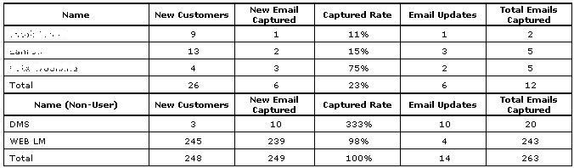
Name - Employee Name
New Customers - These are new Entities created in DealerSocket by the employee
New Email Captured - These are emails captured the same day that the Entity was created.
Capture Rate - Percentage of emails captured the same day the Entity was created.
Email Updates - This includes any existing Entities that were updated with an Email Address.
Total Emails Captured - Total of New Emails Captured and Email Updates
DMS - Entities created by the DMS
WEB LM - Records created from WebLeads
Results
Your success with DealerSocket depends upon accuracy of data and amount of data. Set the expectation and then use these methods to reach your objective. You will then have good email addresses to do some effective target marketing and drive sales.
~Service Advisor~
Strategic Services Consultant
Phone: ~Sales Person Phone~
Email: ~Reply Email Address~
Support Phone: 949.900.0300 ext. 3
Support Email: support@dealersocket.com



