
.............................
Best Practices
30 Second Sales Checkout
The MGR Dashboard Sales Checkout is a one-stop shop for mantaining the integrity of data inside your CRM. When used right, it will put all aspects of the CRM into place. If you want good ROI from DealerSocket, you will get more return from this area of DealerSocket than any other part of the tool.
A common obstacle to most sales managers, however, is allotting time to do a sales checkout. To remedy this, some dealerships have simplified the check-out process to focus on the essentials. And you can do this in just 30 seconds.
1. Set the expectation

Let your reps know they will need to check-out with a Manager before they go home. They will be responsible for 3 key areas inside DealerSocket: A) Entering all their prospects, B) Completing all their to-dos, C) Setting Appointments.

A. 10 Seconds - New Prospects and Completed Sales Steps
X
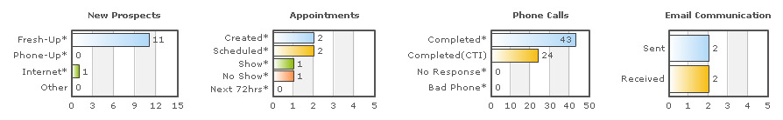
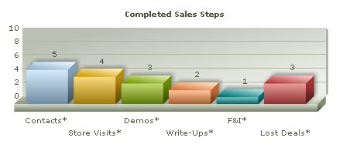

Take 10 seconds to make sure the sales rep has entered all their prospects and how far their prospects progressed.
- New Prospects - Source of each prospect
- Completed Sales Steps - Completed Sales Status of each prospect
B. 10 Seconds - Outstanding To-Dos

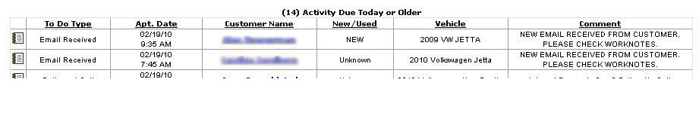
Sales reps need to be held accountable for completing their daily workplans. Any outstanding To-Dos at the end of the day will show up at the bottom of the Daily Check-out Report. This rep has 14 open to-dos.
C. 10 Seconds - Appointments

X
Tracking appointments is pivotal to increasing your sales. If the sales rep has not created any appointments, you can immediately tell 3 things:

1. The Rep is not setting their appointments in DealerSocket and you can not track it.
2. The Rep is cheating the system, not making the call and marking to-dos complete without producing any results.
3. The Rep is making calls but needs additional training on how to sell an appointment.

In the example above, the sales rep made 43 calls and created 2 appointments.
Results
Use the red, yellow, green checklight to track productivity. You will be measuring 3 areas. 1.) Prospects entered, 2.) To-dos Completed, 3.) Appointments Set.
If the sales rep completes:
1 of 3: Red
2 of 3: Yellow
3 of 3: Green
By setting these metrics, your sales reps will begin to drive customers into the show floor and increase their closing ratios.

~Service Advisor~
Strategic Services Consultant
Phone: ~Sales Person Phone~
Email: ~Reply Email Address~
Support Phone: 949.900.0300 ext. 3
Support Email: support@dealersocket.com



