
.............................
Best Practices
Appointment Filters
Car sales is a results based business. The result of good salesmanship is a sold vehicle. Dealerships are great at measuring this. So then, what is the result of good Customer Relationship Management (CRM)?

Appointments.

Appointments are the key to increasing your sales through DealerSocket. Think about this. What is the goal of a referral? Set an appointment. What is the goal of an Internet Lead? Set an appointment. Phone up? Appointment. Unsold Prospect? Appointment. Repeat Customer? Appointment.

The reason you invested in DealerSocket was to get people in the store. You do this by setting appointments.

1. Use Employee Dashboard Filters to Manage Appointments

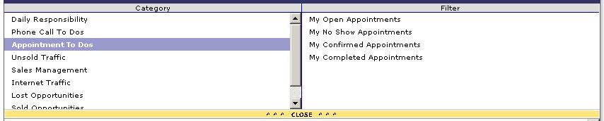

In the Employee Dashboard Filters, train employees to become proficient with the "Appointment To Dos" Category. All of their CRM activity should be pivot around this section. It is broken up into 4 sections:

1. Open Appointments
2. No Show Appointments
3. Confirmed Appointments
4. Completed Appointments

Open Appointments

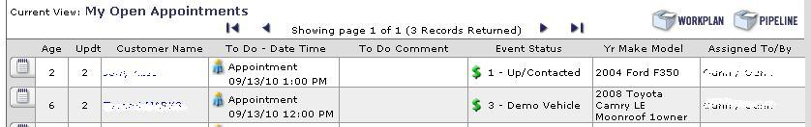

From here you can see all your upcoming "Open" appointments. As you complete your daily to-dos, your main goal is to open an appointment with that customer. Perfect the skill of selling appointments to your customer and increasing the number of appointments you set in DealerSocket.

No Show Appointments

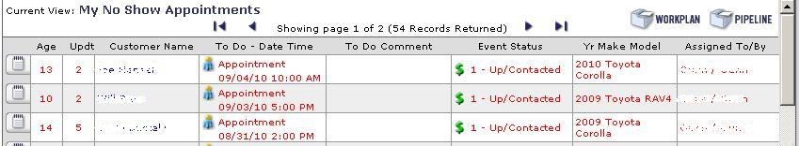

If customers miss their appointment, mark the status of the appointment as "No Show." Of course, your goal with these customers is to reschedule and open a new appointment with them.

Confirmed Appointments

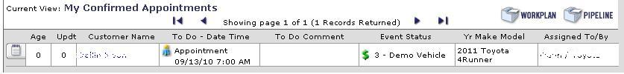
The most important call you can make during the day is an appointment confirmation call. Look through your Open Appointments. Call the customer within 24 hours of the appointments to make sure they are coming in. Use a word track that creates a sense of obligation for the customer to come in..."Customer, I want to make sure you can visualize yourself in the car we are going to test drive, so I'm going to have washed, cleaned, and ready to go. I just need a firm commitment that you are coming in..."

Then update the status of the appointment to confirmed. Try to confirm all your appointments. Once confirmed, the customer will move from the "Open Appointment" filter to the "Confirmed Appointment" filter.

Completed Appointments

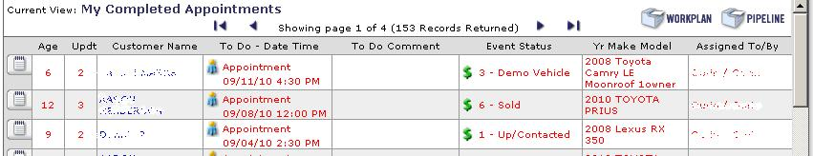
Here you can track the results of your completed appointments. If you didn't get the customer to "Sold." Then, naturally, your goal is to set another appointment with that customer and get them back into the store and close the deal.
Results

The result of good CRM is appointments. All of your activity should revolve around setting and managing appointments in DealerSocket. Use the appointment filters to improve your effectiveness and get more opportunities to close deals.

~Service Advisor~
Strategic Services Consultant
Phone: ~Sales Person Phone~
Email: ~Reply Email Address~
Support Phone: 949.900.0300 ext. 3
Support Email: support@dealersocket.com



